Experiment 8:
AIM:
Create storyboards to represent the user flow for your application using Balsamiq

M.N.Dharaan 240701117
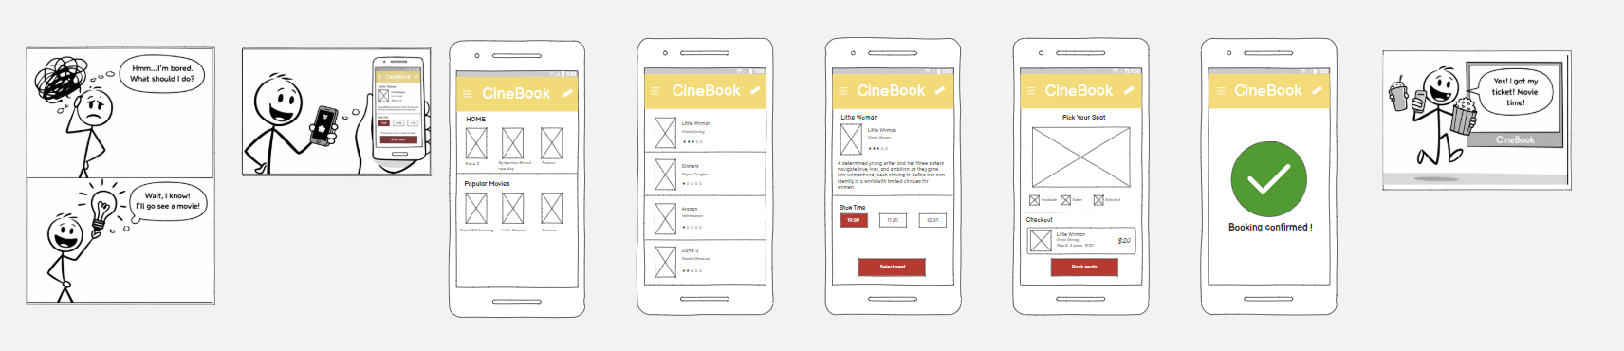

Page 1:
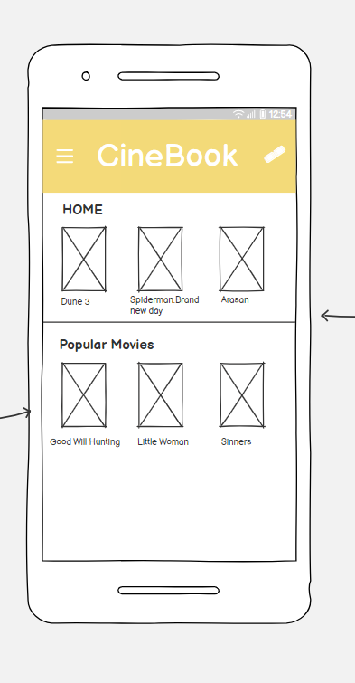

1. Home Page

This is the first screen users see when they open the app. It gives a quick overview of what’s available.
At the top there’s a navigation bar with the app name CineBook and a menu icon.
Below that, featured or recommended movies are displayed in a grid format with posters.
There’s also a “Popular Movies” section, helping users quickly discover trending films.
The layout is simple and visual, encouraging users to browse and pick a movie easily.

Page 2:

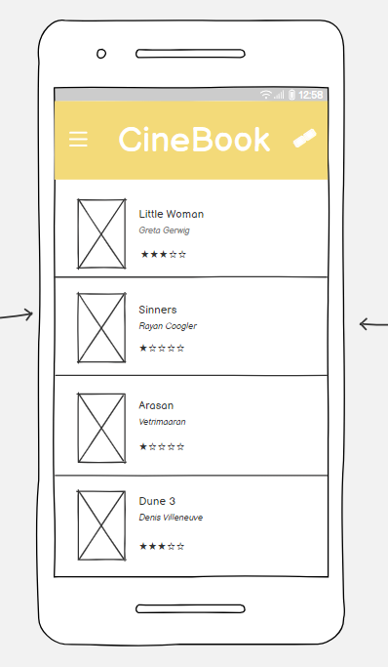

2. Movie List Page
This page shows a scrollable list of movies with basic details.
Each movie appears with a small poster, title, and rating.
The layout is clean and vertical, making it easy to scan multiple options.
Users can tap on any movie to view more details.

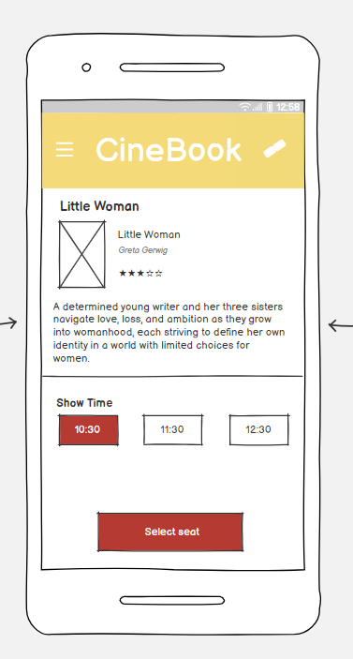
Page 3:

3. Movie Details Page
This screen focuses on a single movie.
Displays the movie poster, title, genre, and rating and log line.
Includes a short log line of the film.
Shows available show timings (like 10:30, 11:30, 12:30).
A “Select Seat” button is placed at the bottom.
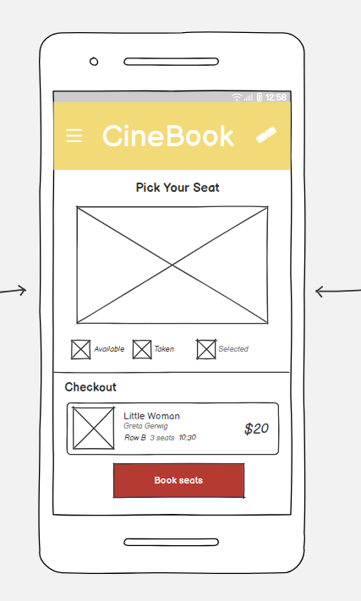
Page 4:

This is where the booking becomes interactive.

A seating layout is displayed with different seat statuses:
- Available seats
- Booked seats
- Selected seats
- Users can tap to choose their preferred seats.
A small summary section shows:
- Movie name
- Number of seats selected
- Total price
A “Book Seats” button confirms the selection.

Page 5:
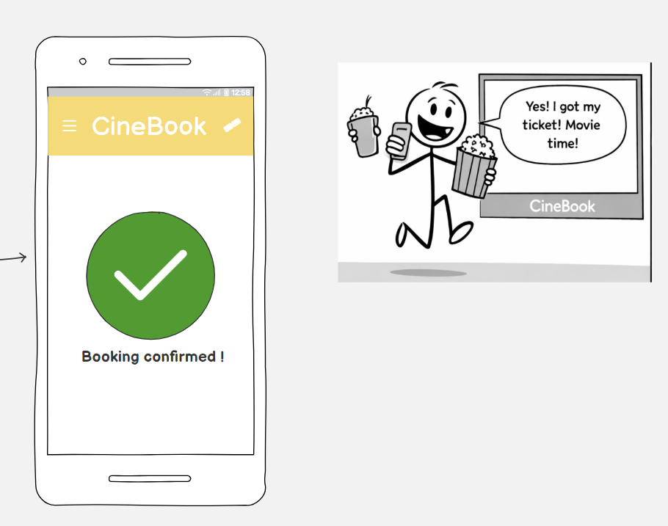

This is the final screen after booking.
A big green checkmark gives a clear success signal.
A message like “Booking Confirmed!” reassures the user.
Minimal design to avoid confusion.

